Peak Petroleum Industries Nigeria LTD

and

Equator Exploration Nigeria LTD

Offshore Nigeria Block OML 122

Bilabri D2

WELL TEST / COMPLETION PROGRAM

Drilling Unit

Semi-Submersible Bulford Dolphin

Well Test Procedure Prepared by: Ray Ismael .K
Completion Engineer – Peak Petroleum – Ismail Ray K.
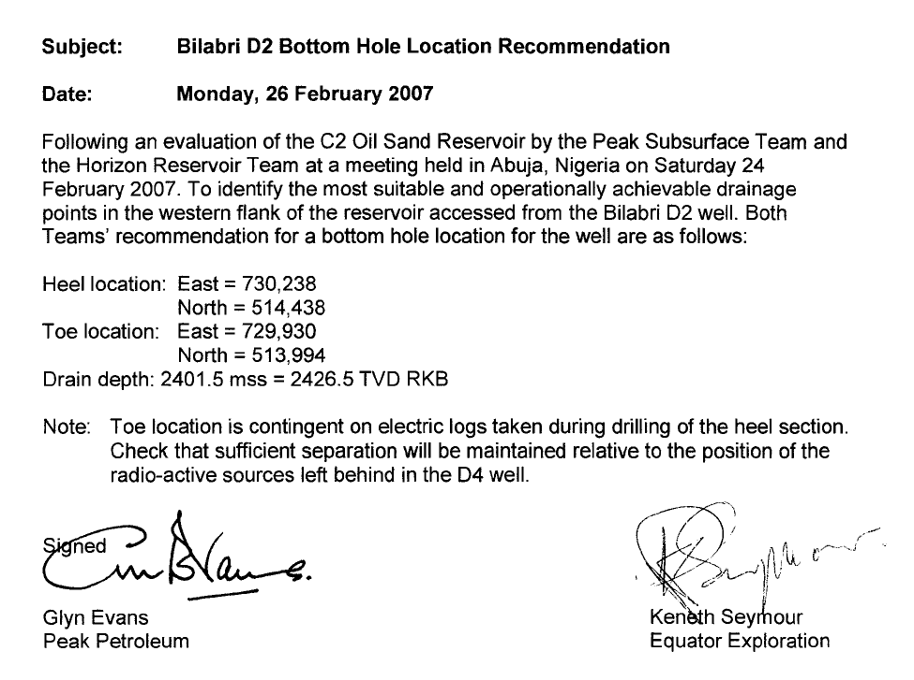

Prepared by:  Ray I.K  Completion Engineer  Date: ___________ | Checked by:  Bobby Roundtree  Tony Gray  Drilling Superintendent  Date: _________ | Checked by:  Mr. Emmanuel Usanga  Sub-Surface Controller  Date: ________ | Checked by:  Russ Gyuatt  Date: __________

Approved by:  Managing Director Peak Petroleum Dr. Ayodeji Oluokin  Date: ___________ | Approved by:  Project Director Peak Petroleum Glyn Evans  Date: ___________ | Approved by:  Managing Director Equator Ken Seymour  Date: ___________ | Approved by:  Chief Operations Officer Equator Philip Dimmock  Date: ___________

Table of Contents
Section 1: Introduction

Section 2: Test Objectives / Basic Well Data

Section 3: Testing Operation Summary
3.1 C2 Horizontal Sands

Section 4: Well Preparation for Test
4.1 Running 6 5/8” OD Reslink 225 Standalone Sand Screens
4.2 Displace SOBM with 10.1 CaCl filtered Brine

Section 5: C2 Operation Procedure
5.1 General Running Procedure
5.2 Flow and Shut in Periods
5.3 Well Kill Procedure

Section 6: Temporary Abandon Procedure

Section 7: General Testing Guidelines

Section 8: General Flowing

Section 9: Well Kill Procedure

Appendix

1. Personnel Responsibilities

2. Safety Guidlines

3. Wellbore Schematic

4. BJ Screens

6 Powerwell Landing String

7. Bulford Dolphin SS BOP Stack Layout

8. Powerwell Surface Test Spread

Section 1: Introduction

Test Objectives
The specific objectives of the C2 production test program for the Bilabri D2 consist of the following:
- Establish maximum sustainable flow at commercial rates.
- Obtain high quality samples for PVT/compositional analysis.
- Estimate Productivity Index (PI) / Inflow Performance.
- Determine completion efficiency (skin).
- Estimate reservoir permeability (radial k and if possible k_{v}/k_{h}).
- Access connected drainage area / presence of any faulting.

The first priority of the Production Test program is to ensure that all operations are carried out safely and efficiently, with due regard for safety of personnel and equipment and for protection of the environment.

Testing will be carried out in accordance with the following procedures:

Operations Procedures:
- Powerwell guidelines for manual sampling and analysis of hydrocarbon fluids
- Peak - Equator Well Test Program

Contractor Reference Documents, Procedures, and Manuals :
- Dolphin Vessel Safety Case
- Dolphin Hazard Identification Report
- Dolphin Formal Safety Assessment including Quantitative Risk Assessment
- Dolphin Safety, Health & Environment Manual (incl. Permit to Work System)
- Dolphin Emergency Response Procedures
- Dolphin Well Control Manual
- Dolphin Marine Operations Manual
- Powerwel Testing Field Operating Manuals
- Baker Atlas Pressure Control Manual

1. Without prejudicing emergency requirements, any deviation from this program which could have safety implications or could significantly affect the test objectives must be approved by Peak - Equator Joint Operating Team.
.
Any deviation from the program must be issued in writing and approval indicated by the signatures of the Peak / Equator Joint Operating Team prior to commencement of any activities covered by the program deviation. Minor procedural variations to the program may be approved offshore by the Peak Completion Engineer, Peak Drilling Supervisor, or Dolphin OIM.

2. Ultimate responsibility for the safety of all personnel on board and for the security of the rig rests with the Dolphin OIM. All matters which could affect the safety of personnel or the rig must be discussed with him or with his appointed delegates, and close liaison between Dolphin, Peak, and Contractor personnel must continue at all times.

3. The Peak Drilling Supervisor is the senior authority offshore responsible for the execution of this program in a safe and sound manner, in accordance with relevant Peak/Equator procedures, government regulations, and relevant industry codes and standards.

4. The Completion Engineer reports to the Drilling Supervisor offshore. The Drilling Supervisor, or his designate, is responsible for the supervision of the activities and personnel covered by this program, though he may delegate responsibility for specific aspects of the program to the Completion Engineer.

5. Prior to the commencement of any new phase of operations the Peak Drilling Supervisor and the Peak Completion Engineer will conduct a safety and operations briefing with relevant crew members.

6. All work to be carried out under this program will be carried out under the Dolphin Permit To Work System. For the duration of the production test phase, the Permit System shall be modified to require the Peak Drilling Supervisor to sign all permits (in addition to the Dolphin OIM).

7. Considering the complications associated with crude, initial flow of hydrocarbons to surface will not be undertaken at night.

8. In the event Hydrogen Sulphide (H₂S) levels above 20 ppm in the wellstream or above 10 ppm in the atmosphere are detected, the well will be shut in down-hole and at surface and the situation assessed with consideration for terminating testing operations.

Section 2: Test Objectives / Basic Well Data

Objective Formations / Test Strategy: C2 : Oil Sand
The S3 sidetrack is aimed to prove-up the oil potential of the C2 sand

Since the C1 sand was mainly gas bearing the well will be plugged back to 13 3/8” casing point at 1650 metres MD and subsequently sidetracked (S3) to the southeast as a horizontal producer in the C2 sand, that was found oil bearing in the Bilabri -1 and Deep -1 wells. Structural control for the C2 horizontal well is very good as the proposed sidetrack is located approximately between the Bilabri-1 and Bilabri Deep-1 well.

Primary Testing Objectives:
- to prove-up the oil reserves in the C 2 sand,
- to appraise the reservoir qualities of the C2 sand
- to establish an oil producer at the C2 sand
- to penetrate the producing reservoirs in an optimal position, with horizontal completions.

The well will be flow tested, to assess reservoir production performance.

During the flow testing of the well, pressure and production data will be gathered to simulate boundary conditions and well productivity.
Oil production from this well may be available from July 2007.
Reservoir specified testing equipment:
1. Running 6 5/8” OD Reslink 225 Standalone Sand Screens.
2. Downhole shut-in capability.
3. Downhole Gauges.
4. Surface PVT sampling

Reporting Requirements:
All reporting of test production data will be the responsibility of the Peak Completion Engineer.
The Completion Engineer will provide well test data to be included in daily drilling report and
organize collection of specific data pertaining to Testing Operations.

Basic Well Test Data:
Well Name: Bilabri D2
Designation: Development Well
License: OML 122

Operator: Peak Petroleum Industries Nigeria LTD
Partner: Equator Exploration Nigeria LTD
Anticipated Spud Date: July 2006
Re-Entry Feb. 2007

Rig: Bulford Dolphin
Rig Contractor: Dolphin Drilling
Rig Type: Aker H3 Semisubmersible

Water Depth: 151m MSL
RKB to MSL: 25 meters

Proposed Surface Location: Lat: 04º 39’ 17.394” N
Long: 05º 04’ 46.574” E
X = 730,700 E
Y = 514,850 N

Projection: UTM Zone 31N
Spheroid: WGS 84
Datum: WGS 84
Type: Universal Transverse Mercator
Central Meridian: 3.0E
Scale Factor: 0.9996
False Northing: 0.00 meters
False Easting: 500,000 meters
Zone 31

Objectives: S1 Pilot – Appraise Oil Rim in C1 Main Gas Sand
S2 Landing – Develop C1 Main Gas Sand
S3 Landing – Fall Back Option to Develop C2 Oil Sand

Casing Setting Depths (RKB): 30” @ 269m (91m below mudline)
20” @ 460m (282m below mudline)
13-3/8” @ 1622m TVD / 1622m MD
9-5/8” @ 2423m TVD / 2784m MD
8-1/2” Drain Hole TD 3422m MD – Screen Completion

Programmed Days: 23.5 days to drill S1 Pilot and S2 Horizontal Drain Hole
11 days to run screens and perform clean-up
34.5 days – Total Estimated Time

Total Depth: 2431m TVD / 3422m MD RKB

Section 3: Operation Summary
Following is a summary of well data

  - C2 Oil Sand

6 5/8” Reslink Standalone Screens + / - 500 meters

Expected Production: Oil
Estimated BHP: 3770 psig @ 2555m MD - Prior Testing Bilabri DX1

Completion Fluid: CaCl @ 10.1 ppg

Test Objectives:

1. Establish reservoir productivity

2. Acquire compositional and PVT samples

3. Assess connected drainage area / presence of any faulting

Test Sequence:

1. Run 6 5/8” Reslink Standalone Screens + / - 500 meters

2. Displace to Brine

3. Clean up on increasing rate with a view to sand control (6 hrs)

4. Build up Period 1 for reservoir re-pressurization (6 hrs)

5. High Rate Flow Period (12 hrs)

6. Build up Period 2 (24 hrs)

Sampling Requirements:

Surface recombination samples will be taken as follows:

1. (3) separator liquid oil samples

2. (3) 20 liter separator gas samples

3. (2) drums of 160 liters each of dead liquids, 10 x 25liter containers

Surface Data Acquisition
Flow Parameter | Time Frequency
Pressure at the Flow Head | 15 Seconds
Pressure before Choke | 1 minute
Temperature before Choke | 1 minute
Pressure after Choke | 1 minute
Separator Pressure | 1 minute
Separator Temperature | 1 minute
Liquid Flow Rate | 1 minute
Gas Rate | 1 minute
Gauge Tank Level | 30 minutes
Annulus Pressure | 15 minutes
BSW / H₂S / CO₂ | As Frequently as possible
Surface Temperature | 1 hour

Subsurface Data Recording

Pressure and temperature will be measured with a frequency of every 5 seconds from 1 hour before to 6 hours after rate change, and otherwise with 1 minute frequency.

Section 4: Well Preparation Testing

COMPLETION PROCEDURE RECOMMENDATION (LOWER COMPLETIO0N)
This procedure assumes the completion fluid system is in place and wellbore clean up has been done. The completion plan for this well involves running and setting 6 5/8” screen on a retrievable seal bore packer in 9 5/8” casing. The well is to be tested as an oil producer with 4 1/2” 15.5# S-135 RTS-6 tubing string with 6” molded seals located in 9 5/8” retrievable seal bore packer.
Make Up and Running of Screen and Packer Assembly (Lower Completion)

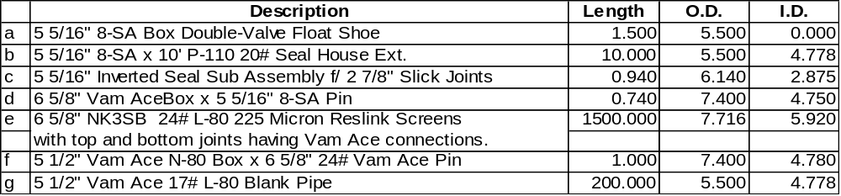MU and RIH with screen and blank assembly consisting of:
Note: Caliper and check tool connections, screen gauge, and record all lengths
Hang off screen and blank assembly with screen table and plate handling system.
Run 2 7/8” HCS washpipe and spaceout with stinger inside inverted seal sub above washdown shoe.

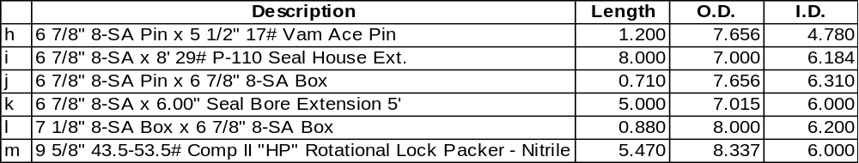PU BJ Services Comp-Set II HP Packer assembly consisting of:

Connect screen and blank assembly to packer assembly. Also connect the packer assembly to workstring and RIH with entire assembly slowly.
Notes:
Ensure all shear pins are in position and the setting sleeve connections are tight. Caliper and check tool connections, and record all lengths.
Handle packer with care, flush the ID with water to ensure nothing is obstructing the ID. Drift workstring while tripping in the hole and have only one drift on the rig floor and do not rabbit any tubing over rotary table. If necessary, sparingly use dope on the work string, pin ends only. Torque all connections to the recommended torque.
Always cover the hole whenever working above the rotary table.

NOTE : Drillpipe, screen and wash pipe tally to be prepared by BJ representative, Peak WellCompletion Engineer and reviewed by Peak Drilling Supervisor, Dolphin toolpusher. Prior to Picking up Screen assemblies, ensure that 2 painted joints are in the work string such that they will be across the BOP rams when at Packer setting depth. The rams will be functioned thereby marking the joints. This will be used for calculating spaceout for the subsesa tree and also stickup ( 4 meters) for the flowhead.

Prior to setting packer, BOPs will be functioned, and a mark using index line ( note tide ) taken with string in neutral position. The string length will be calculated from this mark to the top of the packer. BJ to review and supervise the tally.

4.1 Running 6-5/8” OD Reslink 225 Micron Standalone Sand Screen assembly:

General Notes:
- Ensure the shakers are screened up to 265 mesh and the hole has been circulated and conditioned at the 9-5/8” shoe.

- Screen fluid compatibility test (in appendix) will be performed as per procedure with 6-5/8” screen gauge (225 micron) prior to running screens.

- Ensure the 9-5/8” casing has been pressure tested to 4000 psi and SOBM has been filtered with 265 mesh shaker screens, before picking up Horizontal Open Hole Screen assembly.

Completion Screen Running Procedure:
- Make wiper trip with recommended BHA from BHI Directional Driller after running VSP Log in 8-1/2” horizontal drain hole. Displace open hole to Base Oil from toe to 9-5/8” shoe. Pull back to 9-5/8” shoe. Flow check well for 1 hour to ensure well is static.

- Circulate and condition SOBM to ensure that SOBM has been filtered through 265 mesh shaker screens and perform screen compatibility test procedure.

- Rig up casing handling equipment for 6-5/8” Reslink screens. Screens will be run without centralizers. RIH using correct elevators for screen size.

- Pick up +/-500 meters of 6-5/8” OD 225 micron Reslink Screens with NK3SB box x pin and approximately 150’ – 200’ of 5-1/2” blank pipe. Top and Bottom screen joints are cut to have Vam Ace Box on top connection and Vam Ace Pin on bottom joint. Hang off screen and blank assembly with screen table and plate handling system.
Torque requirements for 6-5/8” NK3SB
Min = 6720
Opt = 8400
Max = 10080

Torque requirements for 6-5/8” Vam Ace
Min = 6510
Opt = 7230
Max = 7950

Torque requirements for 5-1/2” Vam Ace
Min = 4560
Opt = 5060
Max = 5560

- Pick up washpipe according to BJ representative. Connect screen and blank assembly to packer assembly. Also connect the packer assembly to workstring and RIH with entire assembly on 5” workstring. Make up the BJ 9-5/8”, 43.5-53.5#/ft, Comp II HP Packer Assemby as per BJ Service Engineer.

Note:
- Ensure all shear pins are in position and the setting sleeve connections are tight. Caliper and check tool connections and record all lengths with ID and OD.
- Handle packer with care, flush the ID with water to ensure nothing is obstructing the ID. Drift 5” drill pipe workstring to 2.75” ID while tripping in the hole and have one drift on the rig floor and do not rabbit any tubing over rotary table. If necessary, sparingly use dope on the work string, pin ends only.
- Always cover the hole whenever working above the rotary table.
- Ball that will be dropped to set production packer is 2.25” OD steel ball.
- Break circulation every 10 stands to ensure the drill pipe is continuing to fill. Packer can be released from the running tool if a 1200 to 1500 psi differential is created in favor of the annulus side.

- RIH workstring, Lower the system into the wellbore on 5” work string and break circulation before continuing into the well. RIH at a rate not to exceed 1 stand/90 seconds. Rabbit drill pipe while RIH. Before running out 9-5/8” shoe - take Pick Up and Slack Off weights. Break circulation with +/- 5 bbls to ensure ball seat is clear of debris.
Note: Maximum torque for BJ Packer System = 7300 ft lbs if rotating required.

- Run into open hole with 6-5/8” Screen Assembly to end of toe. Tag TD to ensure pipe tally. Space out to be +/-5 feet off bottom. Ensure space out does not put packer setting in collar of 9-5/8” casing. Space out accordingly.

- Pump the DFS-100 cake removal and clean skin. (Baker Fluid)

- Proceed to set the Comp II Packer as per BJ Service Engineer:

- With the packer spaced out and the work string full, drop 2.25” steel ball. Fall rate expected to be 250 feet/min. If the ball has to pumped down to the seat, maintain 1 to 2 bpm – not to exceed 3 bpm and 500 psi surface pressure. PACKER SETTING PRESSURE = 900 psi.

  - Check the OD of the setting ball.
  - Drop ball down drill pipe only.
  - Ball will fall at 4 minutes/1000’
  - Monitor annulus on trip tank and monitor well for losses.

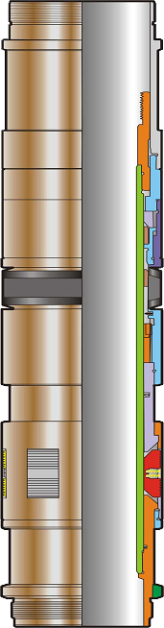

- With ball on seat, pressure up on tubing slowly to 2600 psi in 500 psi increments. At +/-1000 psi the setting sleeve has been activated and the packer will start to set. At +/-2600 psi the setting sleeve on the setting tool has been sheared and the packer set. Bleed work string to 0 psi. Pull tension of 10000 – 15000 lbs on the packer to test the slips are holding.

Note: The packer can not be re-engaged after releasing from it. In an emergency, the SRTS Non Rotational Annulus tool can be released from
the packer with 7 to 9 turns to the right. Place the work string in neutral
or slight tension when releasing with rotation.

- Position work string with neutral weight,mark pipe using the Index line. This reference is critical for calculating spaceout. and test packer with the cement unit by pressuring up and testing the annulus to 1500 psi for 10 minutes. At 1500 psi, the service tool will be released from the packer. Bleed the annulus to 0 psi.

- Snap out of packer and pick up +/-8 feet. Pressure the drill pipe to 2600 psi (2200 psi to 3000 psi range) to blow the ball seat, which will allow circulation through the work string. After shearing the ball seat, bleed the workstring to 0 psi.

- Locate end of packer setting tool +/-5 feet above the packer. Establish circulation rates. Mix and pump displacement pill and filtered 10.0 ppg NaCL Brine (depending on actual RCI Pressures taken in S1 Pilot Hole).
  - 20 bbls of Base Oil
  - 50 bbls of Caustic Pill
  - 100 bbls of MagnaDirt Pill (2.1 gallon/bbl CWAL in filtered SW)
  - 50 bbls of High Vis (5 ppb CWAL Xanpol-P in filtered SW)

- Circulate out to 10.1 CaCL filtered brine. Repeat above process until well clean to +/-150 NTU clarity.

- POOH with packer running and service tools. Lay down same. Lay out washpipe, work string. Note Depth BOP ram marks on pipe. Continue tally to calculate proper depth top of packer. BJ serviceman to verify

Run Completion Screens. Suspend. Pull BOP.
Condition hole to run 6-5/8" OD Production Screens. |  | 1.0
Run 6-5/8" OD Screen assembly. |  | 1.5
 | Total | 2.5
Remove Suspension Plugs. Clean Wellbore. Displace to brine.
RIH with Overshot to retrieve Bridge Plugs. |  | 1.0
RIH with Scraper/Brush Assembly. Clean up wellbore. |  | 1.0
Displace well to Filtered Brine. POOH with Scraper/Brush Assembly. |  | 1.5
 | Total | 3.5
Install Completion String and Tubing Hanger.
RIH with retrieving tool for HSST bore protector with jetting assembly and junk basket. |  | 0.5
Wash BOP and wellhead. POOH. |  | 0.5
M/U 4-1/2" Seal Stack and sub assembly. Run 4-1/2" Prod Tubing Assembly with Gas Lift. |  | 2.0
Run Tubing Retrievable SCSSV. MU Tubing Hanger Assembly. |  | 0.5
Connect Control Lines to SCSSV and Tubing Hanger. Test Same. |  | 0.5
RIH w/ Completion String on SSTT w/ Landing String. Land Tubing Hanger Lock / Test |  | 2.0
 | Total | 6.0
Flow Well. Test HSST. Temporary Suspend.
Prepare to Flow Well. |  | 1.0
Flow to Full Production Capacity. |  | 1
Close SCSSV. Perform Checks on HSST. |  | 0.5
Displace tubing with MeOH Fluid. Retrieve Tubing Hanger Isolation Sleeve. |  | 0.5
Install Tubing Hanger Plug. |  | 0.5
Pull Landing String and SSTT. Rig Down Surface Flow Equipment. |  | 1.0
Wash ITC. Run HSST Internal Tree Cap. Pull IWOCS. |  | 0.5
Pull BOP and Riser. |  | 1.0
Install Debris Cap. Cut Guidelines. Pull Anchors. |  | 2.0
 | Total | 8
Total Days |  | 20
Total Completion Costs | XXXXX $
Running Tubing string procedure.

A. COMPLETION RUN
- RU 4 1/2” tubing running equipment.
- PU sub assembly #1:
- 1 joint tubing 4 ½” 12.6 PH-6
iii. RIH 4 1/2” tubing to first gaslift mandrel depth.
iv. PU gaslift mandrel and continue RIH according to spacing to the last gaslift mandrel depth.
v. RIH 4 1/2” tubing to TR-SCSSSV depth.
vi. PU sub assembly #2 (made-up of 3 ft pop joint, flow couple, TR-ScSSSV, flow couple and 10 ft joint)
vii. PU and make-up one joint 4 1/2” tubing on sub assembly #2.
viii. Connect control line, pressure test and function test TR-ScSSSV on surface.

NOTE:
- Maintain 3000 psi on control line.

ix. Continue RIH 4 1/2” tubing stab into seal bore check stabbing okay with 500 psi in annulus.
x. Space out and pick-up hanger, strap control line.
- Flush port and connect control line to hanger and test to 5000 psi.
- M/U landing joint. Land hanger in DCB spool.
- Drop ball, test tubing and set FH packer
- Test FH packer and seal stabbing in seal bore to 500 psi in annulus.
- Screw down lockdown bolts. Pressure test hanger sealing to 500 psi.
- Back out landing joint. Install NRV in hanger.
- ND BOPs. Retest control line.
- Install xmas + accessories.
- Retrieve NRV. Install TWCV.
- Pressure test xmas tree to 5000 psi

- M/U 4-1/2" Seal Stack and sub assembly.
  - 6” Indexing Mule shoe
  - 6” Molded Production Seals - Nitrite

- Run 4-1/2" Prod Tubing Assembly with 03 Gas Lift Mandrel

- Run Tubing Retrievable SCSSV. MU Tubing Hanger Assembly.

Risk, Risk Mitigation and Contigency
Activity | Risk/Opportunity | Risk Mitigation | Contingency
MU sub assemblies as per requirement and RIH | Inability to run assembly to bottom | Wiper tip prior to running completion  Ensure minimal hole exposure time  Use wiper to run completion  Run completion at 1000ft/hr to prevent packer pre-mature setting | Review completion with team
MU sub assemblies as per requirement and RIH | Inability to re-enter well | Ensure that accessories are calipered and sketch made  All tubular drifted with correct drift  All sectional sketch sent to rig with the assembly  Ensure tubing is landed in tension
MU sub assemblies as per requirement and RIH | Connection failure | Calibrate torque gauges  Inspect all connections  Ensure proper dope  Apply right torque  Pressure test sub assembly before dispatch and attach pressure chart to way-bill
MU sub assemblies as per requirement and RIH | Inability to set packer | QA/QC packer and setting screws | Pull out of hole and change packer  Have back-up on site
Run wireline plug | Inability to attain sealing with plug | Ensure plug is properly dressed  Ensure good brine (NTU)
Run wireline plug | Inability to pull plug | Use PX plug/prong system  Ensure tubular is scale free
Run wireline plug | Leaking on/off connector | Test sub assembly  Reduce yoyo in well
Run wireline plug | Inability to run wireline plug in tubing | QA/QC + drift tubing prior to running | Pull tubing and recheck before re-run
Run wireline plug | Connection failure | Trouble shoot, identify leak, pull tubing and change out leaking connection
Run wireline plug | Inability to attain sealing with plug | Pull plug and redress plug
Run wireline plug | Inability to pull plug with wireline | QA/QC plug + nipple | Pull string.  Have back-up packer and slotted liner
Run wireline plug | Leaking on/off connector | QA/QC on/off connector | Disconnect from the connector and change out seals

1
2
5
6
7
3
4
8
9
10
13
11
12

APPENDIX 1
Personnel Responsibilities

1.1 Peak Drilling Supervisor
Directly responsible for all operations. May delegate responsibility to Peak Completion Engineer during flow & shut-in periods.

1. Ensure operations are professionally managed in a manner that protects the environment, comply with all government regulations, and follow Company policy.
2. Review with key personnel, contingency plans for potential testing emergencies.
3. Co-ordinate the overall conduct of the production test and assign personnel responsibilities.
4. Liase with the Dolphin OIM to ensure that all safety preparations are made.
5. Hold a safety meeting with all personnel involved in testing at an opportune time prior to running the test string and assign personnel responsibilities.
6. Emphasise that all personnel aboard the rig are authorised to shut-in the well using the ESD, if an incident occurs that poses a potentially serious safety hazard to the rig and personnel.
7. Ensure the Permit to Work System is utilized for all test operations. Approve permits as per procedure.
8. Review weather forecasts to ensure the environment conditions will allow an adequate window for the test to be conducted safely.
9. Ensure test procedures are implemented in a safe and efficient manner.
10. Arrange reporting and communications procedures with shore base personnel.
11. Coordinate logistics, including helicopters, and supply vessels with the shore base and at the well site.
12. In coordination with the Dolphin OIM, to ensure that clear instructions are given to the standby vessel during testing.
13. Formally notify the Peak Base Manager prior to opening the well and commencing flaring.

1.2 Peak Completion Engineer
Directly responsible for the all operations. May delegate responsibility to Peak Drilling Supervisor as required during test operations.

1. Quality control of the well test data.
2. Review metering arrangements.
3. Advise data acquisition parameters for memory gauges.
4. Advise on the duration of the flow and buildup periods.
Advise on surface sampling requirements.
5. Determine appropriate choke sizes.
6. Analyse the bottom hole pressure data to ensure test objectives have been achieved.
7. Check and issue daily test report.
8. Witness packer setting. Run and verify correct setting depth for packer.
9. Ensure the test is carried out according to the approved program or that any changes to the program are first agreed to by the relevant personnel.
10. Report to the Peak Drilling Supervisor as required.
- Supervise the testing contractors’ test preparations. Check equipment for completeness and condition.

12. Review and confirm with the respective contractor supervisor, the operating parameters of the entire well testing package and associated equipment :
The Production Test tools
Sub Sea Tree
Surface Equipment
Electronic Gauges
Surface Read-Out
13. Compile the QC file for the well testing operations. Ensure that inspection report for all test equipment are current and on file. Ensure that calculations for space outs, operating pressures and other critical factors are reviewed and signed off by at least 2 competent people and kept on file.
14. Be the focal point for the contractors involved in implementing the test program. Act as liaison between operator, testing contractor and Dolphin to ensure sufficient co-ordination.
15. Act as a technical adviser to the Peak Drilling Supervisor for the planning and operation of the well testing operation.
16. Assist Peak Drilling Supervisor in conducting safety and procedural meetings.
17. The Completion Engineer with ensure that down-hole and surface equipment has been functioned and pressure tested by the relevant Service Company Operators, prior to the commencement of the test.
18. Technical supervision of logging correlation runs to ensure that packer/TCP Guns are set at the correct depth (in conjunction with the Peak Drilling Supervisor).
19. Provide a daily report on the progress and results of the test for the Peak Drilling Supervisor.

1.3 Dolphin OIM
The OIM has overall authority regarding the safety of personnel and the drilling rig and is responsible for the following:

1. Ensuring that all rig equipment is operational as per the Vessel Safety Case.
2. Ensuring the Permit To Work system is implemented, as appropriate, for all test preparations.
3. Organising and conducting fire and rig evacuation drills prior to commencing well testing and ensuring that key personnel are trained in use of breathing apparatus.
4. In conjunction with the Drilling Supervisor and the Base Manager, ensuring that all safety checklists items are addressed and implemented prior to testing.
5. Inform personnel of the basic production test procedure and ensuring that all work is conducted in a safe manner.
6. Liase with the Drilling Supervisor in implementing the detailed step by step production test procedures and any aspects of the Emergency Response Manual or Oil Spill Contingency Plan.

1.4 Dolphin Toolpusher
1. Assist the OIM to perform responsibilities specified above with particular consideration for those aspects that ensure the continuity of testing operations.
2. Check the availability and condition of the necessary tongs, slips and other handling and makeup equipment for the Testing tools, Sub Sea Package, and the Surface Test Tree (STT).
3. Ensure the availability of the necessary stab-in valves for possible use during tripping.
4. Function test the deluge system to ensure adequate protection will be provided during flaring of hydrocarbons.
5. Ensure the Permit To Work system is implemented, as appropriate, for all test preparations.
6. Provide relief for the driller to take scheduled breaks during testing activities.

1.5 Dolphin Driller
1. Remain on the drill floor with two floormen at all times during the test. During flow and build-up periods, the driller may be relieved only by the Dolphin Toolpusher.
2. Immediately report any abnormalities to the Peak Drilling Supervisor or Dolphin Toolpusher.
3. The Driller is to be familiar with the Surface Test Tree (STT) Emergency Shut Down (ESD) system and the mode of operation.
4. Ensure that one person (Assistant Driller or Derrickman) is in the pump room at all times to line up kill fluids to the cement unit or mud pumps as required by operation.
5. Monitor annulus pressure and trip tank volume through the flow and build-up periods. Record pressures and volumes every 15 minutes.
6. Keep a check on wind duration during flaring operations and inform the Peak Completion Engineer, the Powerwell Supervisor, and Barge Master in case switching flare booms needs to be considered.

1.6 Dolphin Radio Operator
1. Make a register of all portable radios and telephones onboard the rig. Ensure all transmitters are collected and secured prior to radio silences.
2. As and when necessary, implement “Radio Silence” procedures and notify shorebase when Radio Silence will be in effect and when communications are re-established.
3. Liase with supply vessels and warn other vessels to remain outside the safety zone around the rig during testing operations.
4. Keep the helicopter base advised of expected flaring times.

1.7 Dolphin Barge Master
1. Ensure all fire fighting and life saving equipment is ready for immediate use.
2. Ensure all cooling and wet-down equipment is in position and tested.
3. Brief crew regarding testing-related duties and ensure such duties are carried out.
4. Obtain latest weather information and brief OIM.
5. Monitor wind and weather conditions during test period and report accordingly to OIM.
6. Ensure there are persons with radios on boom watch during flaring.
7. Ensure PTW system is implemented with regard to hot work.
8. Ensure Radio Operator has completed all his duties relating to Testing operations.

1.8 Supply Vessel Captain
1. Review supply vessel responsibilities and duties.
2. Maintain station upwind of the rig as instructed by the Dolphin OIM.
3. Watch for oil spills and report immediately to the Barge Master.

1.9 Powerwell Test Supervisor
The Powerwell Test Supervisor is the focal point for the testing crew, including surface and downhole test personnel, gauge and electronic data acquisition technicians. In general, instructions for the testing crew will be passed through him and reports will be issued through him. His duties therefore include the following:

1. Supervise and co-ordinate the Powerwell & test personnel and the activities being performed.
2. Liase with the Peak Drilling Supervisor and Peak Completion Engineer to ensure all activities are carried out safely and efficiently.
3. Brief test personnel on the testing procedures and their responsibilities.
4. Review inventory quantities and condition, of all Powewell & test equipment onboard. Make sure adequate backup and spares are available.
5. Initiate Permits to work covering all Production Test Activities.
6. Organise and co-ordinate pressure and function testing in compliance with the Permit To Work system.
7. Ensure all rig supervisory personnel are aware of the location and operation of emergency shut down equipment.
8. Ensure well testing results are kept up-to-date and are accurate. Ensure that necessary factors and parameters are applied prior to rate calculations.
9. Provide the Peak Drilling Supervisor and Peak Completion Engineer with testing results (flowrates, pressures, etc.) as required.
10. Maintain good communications and co-operation with Dolphin personnel, from the OIM down, to help ensure the smooth installation of the equipment and implementation of the program.
11. Provide Peak personnel with a test string schematic complete with IDs, ODs, connections, volumes, and lengths prior to running any equipment in the hole.

1.10 Downhole Tools Supervisor
1. Make up, function, and pressure test the downhole tools.
2. Prepare a report detailing the running list, with all critical dimensions and operating pressures.
3. Check the availability of the necessary tongs, slips and other handling and makeup equipment for the Testing tools and Sub-Sea Package.
4. Ensure that adequate backup equipment and spares are available at the rig.
5. Maintain a “status board” showing the status of all Testing valves and the Select Tester Valve, and keeping track of the cycles on these tools.
6. Man the rig floor at all times to instruct the driller in the correct operation of annulus pressure tools and the optimum running speed while tripping.

1.11 Powerwell Data Acquisition Supervisor
1. Ensure all data acquisition equipment is functioning correctly.
2. Co-ordinate calibration of gas, oil and water meters.
3. Check data-downloading capabilities, reporting and plotting software is functional.
4. Ensure adequate batteries and spares are available.
5. Double check results from Data Acquisition system against manually calculated results to ensure correct parameters are entered in the system.

1.12 Downhole Gauge Engineer
1. Check bottom hole gauges are functioning correctly.
2. Ensure adequate supplies of spares and batteries are available.
3. Advise Well Completion Engineer on gauge set up parameters to record data.
4. Download data from gauges in the format required by Peak.
5. Produce plots and report of the bottom hole pressure data.
6. Quality control the pressure data to ensure the gauges are performing to specification.
7. Pressure test the gauge carriers as required.

1.13 Powerwell Chief Operator
1. Ensure adequate sampling bottles and dead fluid containers are available for the intended sampling program.
2. Prepare the bottles as necessary for sampling (evacuation of gas bottles) and ensure bottles have been cleaned.
3. Acquire samples as per program, following standard procedures to assure the quality of the samples for analysis.
4. Prepare a list of all samples acquired and prepare samples for shipment as per Peak Completion Engineer.
5. Ensure availability of appropriate fittings to transfer samples from Halliburton RD sampler to Powerwell’s PVT sample cylinder.

1.14 Baker Atlas Logging Engineer
1. Ensure that the surface test tree stick up takes into account Pressure Control Equipment dimensions. Review explosives safety procedures with Drilling Supervisor and ensure that all safety procedures are followed when handling explosives.
2. Liase with the Peak Drilling Supervisor and Dolphin Radio Operator for the implementation of “Radio Silence” if required during operations.

1.15 BJ Cementer
1. Function and pressure test the cement lines.
2. Operate the cement unit pumps to perform pressure testing, calibration and displacement as directed by the Well Completion Engineer, Powerwell Test Supervisor or the Halliburton Downhole Tools Technician.
3. Review well kill procedures with the Drilling Supervisor.
4. Line suction up to pump kill fluid and be ready to implement well kill procedures at short notice.

1.19 Petrolog Mud Loggers
1. Take periodic gas samples from the separator for chromatograph analysis.
2. Monitor gas detectors in the shaker area, moon pool and on the rig floor.
3. Monitor annulus pressure, trip tank volumes and flow detector.

1.20 Baker Hughes Mud Engineer
1. Maintain completion fluid properties as specified in the test program.
2. Ensure adequate volumes are on hand to kill the well.
3. Analyse produced fluids for salinity and pH as requested by the Completion Engineer.

1.21 Weatherford Tubing Running Services Supervisor
1. Inspect and strap all tubulars under supervision of the Peak Completion Engineer.
2. Ensure all handling equipment is in place.
3. Ensure correct handling and running procedures are implemented when running/retrieving the string.

APPENDIX 2

Safety Guidlines

Semisubmersible Movement Limitations:

Heave

Max < 3.0 meters All operations proceed as normal

Max > 3.0 meters Shut in Well at STV and SSTT

Roll and Pitch

Max < 3.0 degrees All operations proceed as normal

Max > 3.0 degrees Shut in Well at STV and SSTT

Rig Offset to Wellhead

Max < 1.25% Water Depth All operations proceed as normal

Max > 1.25% Water Depth Shut in Well at STV and SSTT

Yellow Alarm @ 1.5% WD Disconnect SSTT

Red Alarm @ 5.5% WD Disconnect Drilling Riser and LMRP

PRE-TEST
This section details safety policies and procedures to be adhered to during the testing program. The Peak Drilling Supervisor and the Dolphin OIM are responsible for addressing each item and ensuring compliance with the policy or procedure.

These guidelines are intended to complement the policies and procedures contained in the manuals referenced in Section 1.

1. Ensure all the required emergency response equipment is on board the rig and is in good working order. This will include, but not be limited to, life boats, fire extinguishers, fire-fighting equipment, breathing apparatus, gas detectors, emergency lighting, PA system, and all lifesaving equipment.

2. Ensure that all H₂S safety equipment is deployed and operable, and all personnel are trained in its use.

3. Ensure that only the essential personnel during testing are on board and that non-essential personnel are sent to base.

4. The surface testing equipment is to be inspected to ensure that all lines are properly routed, installed, secured and, where required, electrically grounded. All components to be pressure tested with water and a report submitted to the Drilling Supervisor, including pressure testing charts.

5. BOP and well control equipment to be pressure tested prior to the testing program.

6. Emergency Shut Down (ESD) stations will be installed on the rig floor, the testing area and outside the accommodation block. Ensure that the system has been tested and is operable.

7. A pre-test safety meeting is to be held with each rig crew to discuss safety during well testing operations. Service personnel and PEAK personnel will attend both meetings to answer any questions and concerns. Testing procedures, lines of authority and responsibility and deployment of safety equipment will be discussed. Where there is a crew change, a safety meeting will be held with the new crew as soon as possible.

8. Rig evacuation and fire drills will be held before each test. Personnel arriving on the rig after the evacuation drill will be given a demonstration of procedures if a drill is not scheduled before the next test.

9. Define the exit routes from the test area and ensure they are clearly understood.

10. The Permit To Work system will be adhered to at all times. No hot work permits will be issued during well testing operations.

11. The standby vessel will be stationed upwind of the rig and be prepared to provide immediate assistance as required. Standby vessel crews should be drilled in the correct standby and support procedures.

12. Confirm that gas detection equipment is operational and properly calibrated.

13. Ensure that the compressors are fitted with spark arrestors, air supply intakes are in a designated safe area and emergency shut down systems are operational.

14. Atlas / Halliburton procedures for handling explosives will be strictly adhered to.

15. Helicopter flights will be restricted during testing at the discretion of the PEAK Drilling Supervisor and the Dolphin OIM.

16. Ground all production vessels including sampling vessels to avoid static electricity ignition sources.

17. Ensure all required personnel are trained and familiar with any safety equipment which they may be expected to operate.

18. Review systems for shutting down non-essential electrical equipment.

- Pressure testing will be conducted in compliance with the Permit To Work system. Pressure testing areas will be cordoned off and non-essential personnel warned to stay clear.

- Ensure that separator levels are monitored closely during flow periods, particularly after bean ups, to ensure no liquid slugs flood the separator.

PRIOR TO FLOWING THE WELL

The initial flow of hydrocarbons to surface will not be undertaken at night without prior approval from the Peak/Equator Joint Operating Team. Subsequent flow periods from the same zone may be recommenced at night at the discretion of the Peak Drilling Supervisor and the OIM.

- Hold a rig floor safety meeting with all the rig crew and service company personnel involved in the testing operations to discuss responsibilities and the sequence of events. At this time, situations when the Emergency Shut Down (ESD) system would require activation will be discussed, the procedure to operate the ESD system will be demonstrated and the Surface Safety Valve reset.

- Place laminated copies of the surface layout, including location of ESD stations, on exits from the accommodation.

- Remind all personnel of the strict adherence to safety regulations, especially no smoking outside the living quarters, and all hot work permits suspended.

- Peak/Equator Joint Operating Team shall advise the Government bodies that well testing is about to commence.

- Advise the supply vessel to assume a position upwind of the rig and that well testing is about to commence.

Note: The Supply boat must not be at anchor during testing operations from the time of flowing the well until the well is killed.
Note: Clear & non-conflicting instructions must be given to the supply vessel captain at all times.

- Deploy the fire fighting equipment and assign personnel to fire watch.

- Assign personnel to tour the testing areas with gas detectors, and deploy breathing apparatus with procedures to follow if there is evidence of H₂S.

- All doors, hatches and vents in the vicinity of the test equipment will be closed for the duration of the test.

- Working on burner booms shall require a Permit To Work and it should be emphasised that work vests must be used when working on the booms.

- Cranes will not be operated when the well is open to flow. Limited crane operations will be permitted during shut in periods at the discretion of the PEAK Drilling Supervisor and the Dolphin OIM(but no lifts over pressurised lines or vessels will be permitted).

- Prior to flowing the well an announcement will be made over the intercom that well testing is about to commence.

WELL TESTING
- Considering the difficulties associated with burning waxy crude, initial flow of hydrocarbons to surface will not be undertaken at night without prior approval from the Peak/Equator Joint Operating Team. Subsequent flows from the same zone may be conducted at night at the discretion of the PEAK Drilling Supervisor and the Dolphin OIM.

2. Check H₂S concentration in produced fluids as soon as possible. If well-stream concentrations greater that 20 ppm are recorded the Drilling Supervisor is to be advised and the advisability of continuing the testing operations must be immediately assessed.

3. Frequent checks should be made for sand production at the choke manifold (BS&W samples and at the choke box when changing choke). If excessive quantities of unconsolidated sand are produced the advisability of continuing the testing operations must be immediately assessed.

4. Permit must be obtained prior to and life jackets must be worn when working on the burner booms.

5. Supply vessel will maintain a constant alert upwind of the rig.

6. The radio room will be manned at all times during testing operations.

7. Helicopters will be permitted to land on the drilling vessel during well testing at the discretion of the PEAK Drilling Supervisor and the OIM.

8. A PEAK representative shall be present on deck at all times during all well testing operations.

9. Non-essential personnel will keep clear of the rig floor and the test equipment areas during well testing operations.

10. The cement unit shall be connected to the kill line on the Surface Test Tree (STT) and be ready to start pumping immediately, if required.

11. Before pulling the test string, the string contents will be reverse-circulated. The well will be circulated at least once the long way around. All hydrocarbon contaminated mud will be circulated out and flow checks conducted before starting out of the hole, every 20 stands, and before pulling the lower test string through the BOP stack.

12. A stabbing valve will be available on the floor ready for use, with all necessary crossovers for any component of the test string.

13. The driller or Dolphin Toolpusher must be on the rig floor at all times during flow and shut in periods. The assistant driller is not permitted to act as the relief for the driller.

- Cordon off the area between the “V” door and the wireline unit during wireline operations.

- All personnel aboard the rig are authorised to shut-in the well using the ESD, if an incident occurs that poses a potentially serious safety hazard to the rig and personnel.

SAFETY MEETINGS, DRILLS AND ALARMS

SAFETY MEETINGS
Prior to commencing testing operations, a safety meeting will be held where the PEAK Drilling Supervisor and Well Completion Engineers will brief the drilling crew, service company representatives, and all key personnel on board on the planned sequence of events, potential hazards, and planned responses to emergencies. Personnel responsibilities have been defined and the procedures should be reviewed with an emphasis on the safety systems in place.

A discussion of safety issues should be encouraged at the meetings. Guidelines for issues to be addressed are as follows:

- Restricted areas and work activities.
- Review of station drill.
- Fire fighting equipment deployment.
- Personnel rescue.
- Safety rules and policies, including no smoking and hot work.
- Rig evacuation procedures.
- Security of information and communications between rig and shore.
- Safe pressure testing procedures.
- Designate teams of personnel for fire watch and monitor for gas and H₂S.
- Planned test procedures and equipment involved.
- Operation of alarms, warning signals and the appropriate reactions.
- Explanation of the emergency shut-down system.
- Contingencies for downhole leaks.
- Emphasis on good housekeeping, especially where test personnel are operating.

DRILLS
Fire, Man Overboard, Abandon Rig and BOP drills are to be held before starting testing operations. Drills simulating a fire at the separator or an explosion at the shakers, or a release of H₂S, will be conducted.

Training and drills in the use of H₂S safety equipment, particularly self-contained breathing apparatus, should be completed prior to testing.

ALARMS
All H₂S sensor alarms, explosive limit gas alarms, and smoke detectors must be tested and in working order prior to perforating the well. Actual alarms should be used to initiate drills to familiarise personnel with the various alarms.

APPENDIX 3

Wellbore Schematic

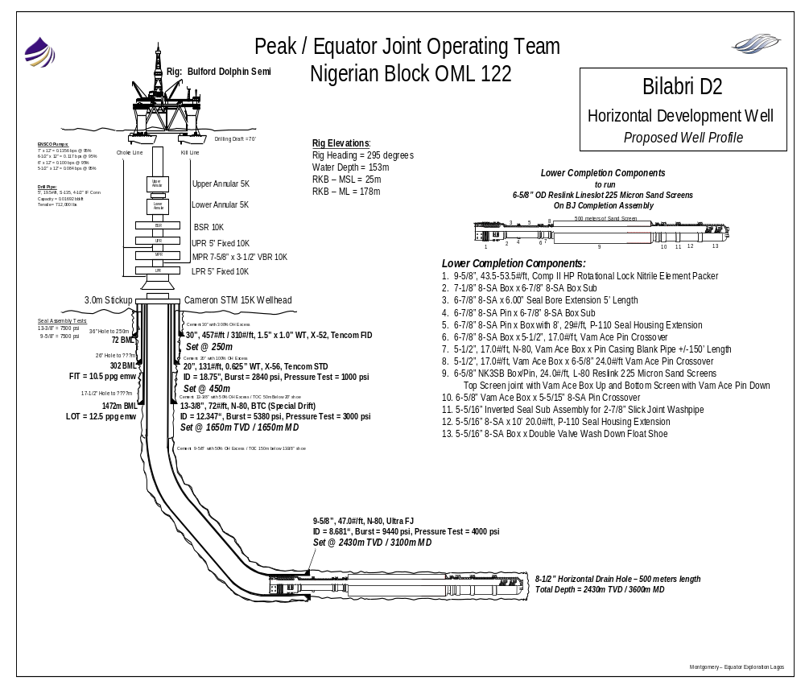

APPENDIX 4 BJ

BJ 6 5/8” Open Hole Screens Test String Components

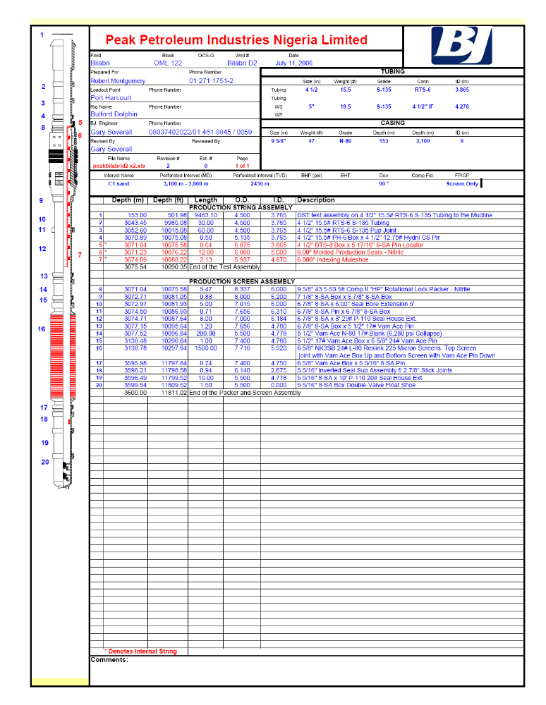

APPENDIX 5

9 5/8” Casing Test String Components

APPENDIX 6

Powerwell Landing String Diagram

DRAFT – NEW SCHEMATIC TO BE SUPPLIED

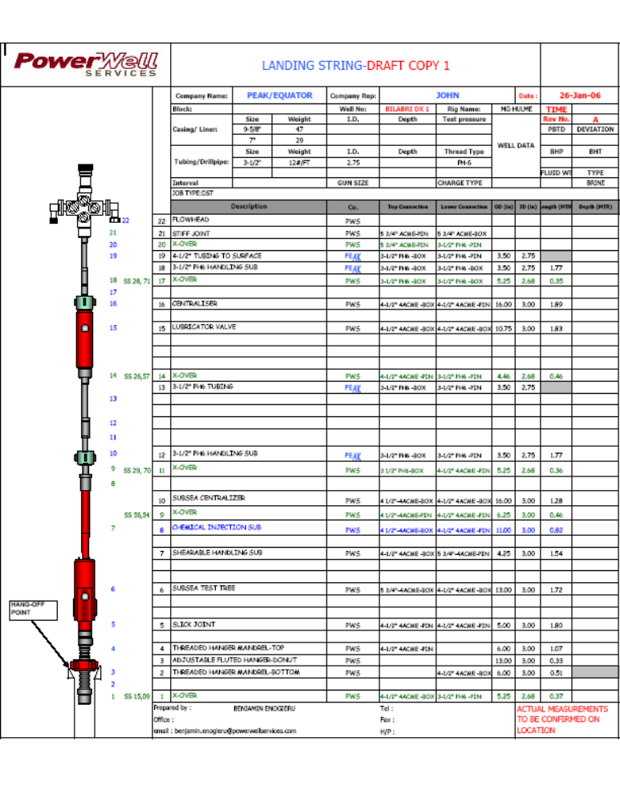

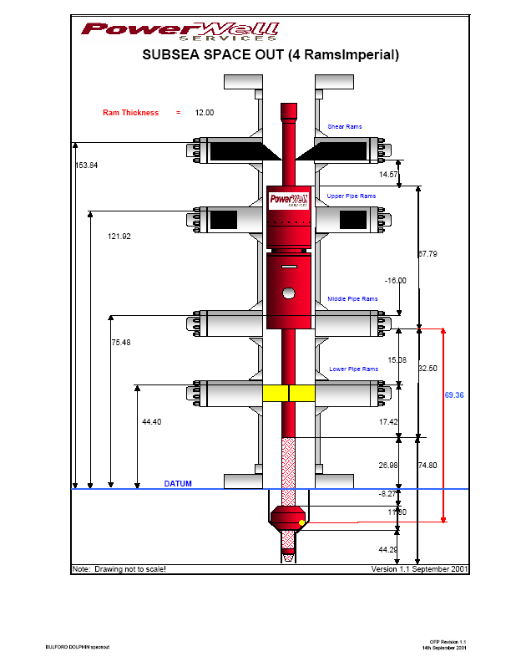APPENDIX 7 Bulford Dolphin SS BOP Stack Layout

APPENDIX 8

Powerwell Surface Test Spread
